**Music sales**

**Q1 Who is the senior most employee based on job title?**

select * from employee

order by levels desc

limit 1

**Q2. Which countries have the most Invoices?**

Select count(*) as c, billing_country

from invoice

group by billing_country

order by c desc

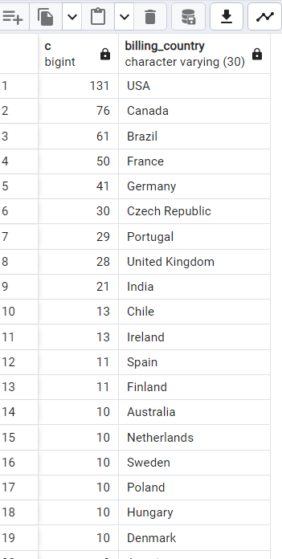

**Q3. What are the 3 values of total invoice?**

select total from invoice order by total desc

limit 3

**Q4. Which city has the best customers? we would like to throw a promotional Music Festival in the city we made the most money. Write a query that returns one city name & sum of invoice totals.**

select sum(total) as invoice , billing_city from invoice

group by billing_city

order by invoice desc

Q5: Who is the best customer? The customer who has spent the most money will be declared the best customer. Write a query that returns the person who has spent the most money.

select customer.customer_id, customer.first_name, customer.last_name, sum (invoice.total) as total

from customer

join invoice on customer.customer_id = invoice.customer_id

group by customer.customer_id

order by total desc

limit 1

**Q6: Write query to return the email, first name, last name, & Genre of all Rock Music listeners. Return your list ordered alphabetically by email starting with A.**

select distinct email, first_name, last_name

from customer

join invoice on customer.customer_id = invoice.customer_id

join invoice_line on invoice.customer_id = invoice_line.invoice_id

where track_id in

(select track_id from track

join genre on track.genre_id = genre.genre_id

where genre.name like 'Rock'

)

order by email

**Q7. Let's invite the artists who have written the most rock music in our dataset. Write a query that returns the Artist name and total track count of the top 10 rock bands.**

select artist.artist_id, artist.name, count(artist.artist_id)as number_of_songs from track

join album on album.album_id = track.album_id

join artist on artist.artist_id = album.artist_id

join genre on genre.genre_id = track.genre_id

where genre.name = 'Rock'

group by artist.artist_id

order by number_of_songs Desc

limit 10

**Q8. Return all the track names that have a song length longer than the average song length. Return the Name and Milliseconds for each track. Order by the song length with the longest songs listed first.**

select name,milliseconds

from track

where milliseconds > (

select avg (milliseconds) as avg_track_length

from track

)

order by milliseconds desc

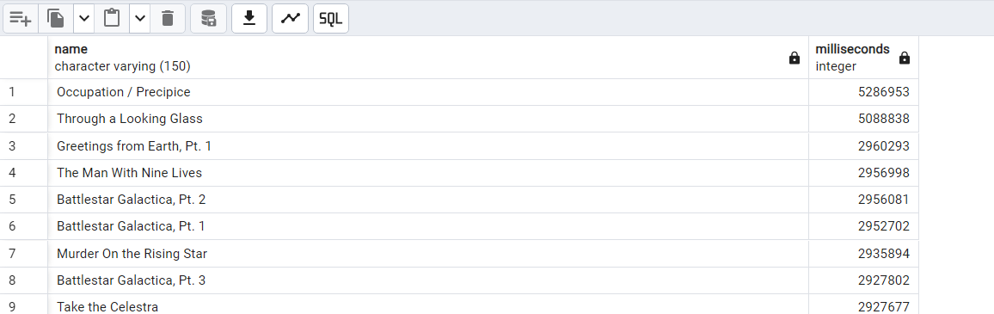

Q1: Find how much amount spent by each customer on artists? Write a query to return customer name, artist name and total spent

with best_artist as (

select artist.artist_id as artist_id, artist.name as artist_name,

sum (invoice_line.unit_price* invoice_line.quantity) as total_cost

from invoice_line

join track on track.track_id = invoice_line.track_id

join album on album.album_id = track.album_id

join artist on artist.artist_id = album.artist_id

group by artist.artist_id

order by total_cost desc

limit 1

)

select customer.customer_id, last_name, first_name, best_artist.artist_name,

sum(invoice_line.unit_price * invoice_line.quantity) as amount_spent

from invoice

join customer on customer.customer_id = invoice.customer_id

join invoice_line on invoice.invoice_id = invoice_line.invoice_id

join track on track.track_id = invoice_line.track_id

join album on album.album_id = track.album_id

join best_artist on best_artist.artist_id = album.artist_id

group by 1,2,3,4

order by amount_spent desc

Q2: We want to find out the most popular music Genre for each country. We determine the most popular genre as the genre with the highest amount of purchases.

with genre_table as (

select genre.genre_id, genre.name, count(invoice_line.quantity) as purchase, customer.country, row_number() over(partition by customer.country order by count (invoice_line.quantity)Desc) as row_no

from invoice_line

join invoice on invoice_line.invoice_id = invoice.invoice_id

join customer on customer.customer_id = invoice.customer_id

join track on invoice_line.track_id = track.track_id

join genre on track.genre_id = genre.genre_id

group by 1,2,4

order by 4 asc, 3 desc

)

select * from genre_table where row_no <=1

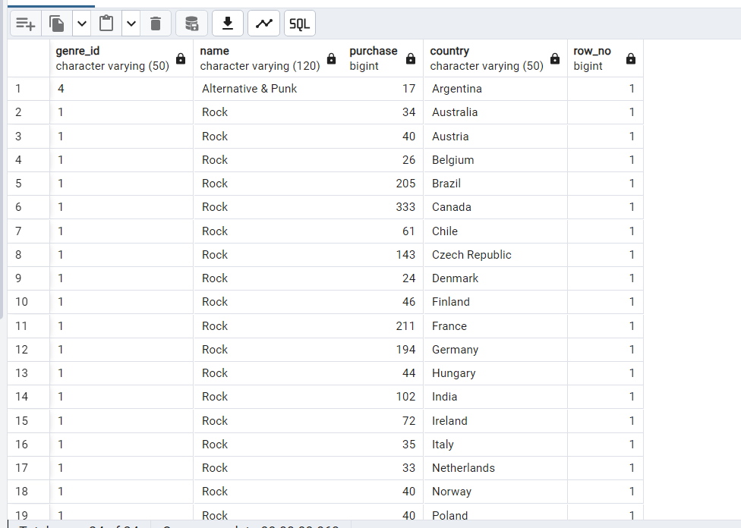

Q3: Write a query that determines the customer that has spent the most on music for each country. Write a query that returns the country along with the top customer and how much they spent. For countries where the top amount spent is shared, provide all customers who spent this amount.

with recursive

customer_with_country as (

select customer.customer_id, last_name, first_name, billing_country, sum(total) as spent_money

from invoice

join customer on customer.customer_id = invoice.customer_id

group by 1,2,3,4

order by 1, 5 desc),

country_max_spending as(

select billing_country,max(spent_money) as spending

from customer_with_country

group by billing_country)

select cc.billing_country,cc.spent_money,cc.last_name,cc.first_name,cc.customer_id

from customer_with_country cc

join country_max_spending ms on cc.billing_country = ms.billing_country

where cc.spent_money = ms.spending

order by 1

